Operations Guide

FX-CLEAR PLATFORM

TABLE OF CONTENTS
1 | Introduction | 4
1.1 | Purpose of the Document | 4
1.2 | Scope of the Document | 4
1.3 | Organization of the Document | 4
2 | Start of Day Operations | 5
3 | End of Day Operations | 6
4 | Check List | 7
4.1 | Start of day operations | 7
4.2 | End of day operations | 7

Introduction

  - Purpose of the Document

This document provides the guidelines for operating FX-CLEAR Member Gateway.

  - Scope of the Document

This document will provide the user with guidelines for operating FX-CLEAR Member Gateway . The functionality and usage instructions for various business modules are not a part of this document and are covered in separate user manuals.

  - Organization of the Document
The document is organised as follows:
- Section 2 contains Start of day activities.
- Section 3 contains End of day activities.
- Section 4 contains FX CLEAR Checklist.

Start of Day Operations

1.Double click on the FX-CLEAR Member Gateway shortcut icon on the desktop
Double click on this Member GatewayIcon

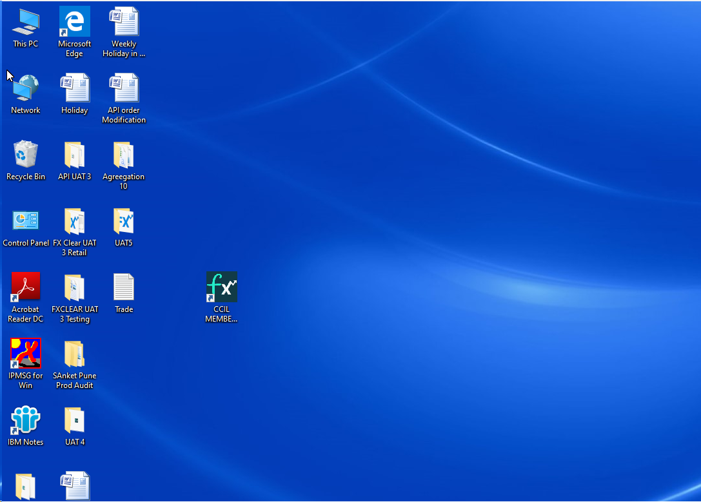

2. When the Member Server is connected, the icon is displayed on the right corner of the taskbar, with a tooltip, displaying the FX-CLEAR Member gateway started successfully message.

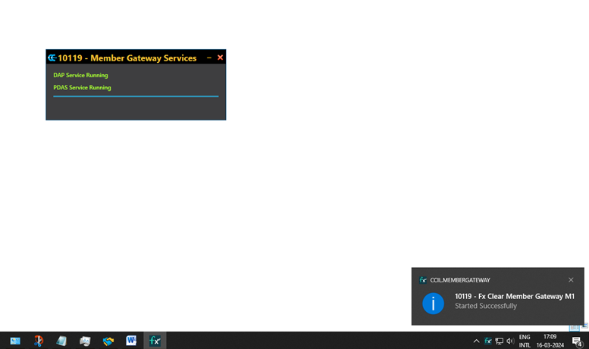

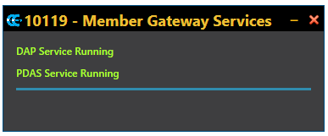

End of Day Operations

After all the FX-CLEAR Dealing System Users are logged off, Stop FX-CLEAR Member Gateway. For this click on the Close icon of FX-CLEAR Member Gateway and click on stop Member Server.

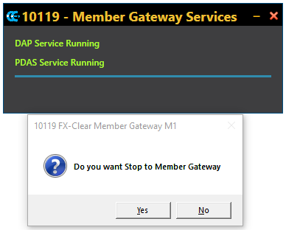

Click on “YES”

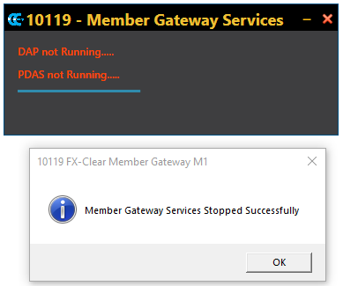

Check List
Start of day operations

Sr No # | Activity | Verified
1. | Start FX-CLEAR Member Gateway
2. | FX-CLEAR Member Gateway started successfully
3. | FX-CLEAR Dealer Workstations are logged in successfully

End of day operations

Sr No # | Activity | Verified
1. | All FX-CLEAR Dealer Workstations are logged off successfully
2. | FX-CLEAR Member Gateway stopped successfully

